

**TEST STRATEGY DOCUMENT  
*for***

***The Scottish Education Forum   
(Dundee Primary School)***

|  |  |
| --- | --- |
| **Project Name** | Numeracy |
| **Project Number** | 01234 |
| **Prepared for** | Iain Crawley (Project Manager) |
| **Prepared by** | Robert Lothian |
| **Class** | HND Computer Science 1 |
| **Document Creation** | 04/05/2021 |
| **Last Updated** | 21/05/2021 |
| **Date Submitted** | 21/05/2021 |
| **Version** | 01 |
| **Security Classification** | Low |

# Document Control

# Revision History

|  |  |  |  |
| --- | --- | --- | --- |
| **Revision No** | **Revision Date** | **Description of Change** | **Author** |
| 00 | 10/05/2021 | Document Design Updated | Fred Brown (System Analyst) |
| 00 | 11/05/2021 | Pseudo Code Updated | Linda Smith (Programmer) |
| 00 | 12/05/2021 | Test Case Data Agreed | Iain Crawley (Project Manager) |

# Document Detail

|  |  |
| --- | --- |
| **Title** | Numeracy |
| **Version** | 0.1 |
| **Date** | 04/05/2021 |
| **Electronic File Name(s)** | Numeracy.java |
| **Electronic File Location** | Canvas |
| **Author** | Robert Lothian |
| **Contributors** | Fred Brown (System Analyst), Linda Smith (Programmer), Iain Crawley (Project Manager) |

# Referenced Documentation

|  |  |  |
| --- | --- | --- |
| **Ref** | **Document Name** | **Electronic File location** |
| 567 | Requirement Specifications | Canvas |
| 568 | Design Requirements | Canvas |
| 569 | Java Numeracy Coding | Canvas |

# Team Members and Roles

|  |  |
| --- | --- |
| **Resource Name** | **Role** |
| Iain Crawley | Project Manager |
| Linda Smith | Programmer |
| Fred Brown | System Analyst |
| Robert Lothian | Software Tester |

# Diary/Log of Errors

|  |  |  |
| --- | --- | --- |
| **Date** | **Error Description** | **Action** |
| 20/05/21 | Syntax – Wrong message displayed when option 5 selected (fig 1a) | Fixed error and change message to match the option (fig 1b) |
| 20/05/21 | Logic - The multiplication function adds instead of multiplies (fig 2a) | Changed the operator from + to * (fig 2b) |
| 20/05/21 | Run-Time – The program crashes if user divides by 0 (fig 3a) | Added a contingency warning the user that they cannot divide by 0 and prompts them to enter another number (fig 3b) |

Table of Contents

Contents

Document Control 2

Revision History 2

Document Detail 2

Referenced Documentation 2

Team Members and Roles 2

Diary/Log of Errors 2

1.0 Introduction 4

2.0 Objectives 4

3.0 Scope 4

4.0 Test Items 4

5.0 Testing Methods 4

6.0 Testing Strategy 4

7.0 Testing Levels 5

7.1.1 Unit Testing *……...*7.1.2 Systems Testing 5

7.1.3 Acceptance testing 5

8.0 Entry Criteria 5

9.0 Exit Criteria 5

10.0 Environmental Needs 5

11.0 Staffing and Training 5

12.0 Test Schedule 5

13.0 Risks and Contingencies 6

14.0 Approvals 6

Appendices 7

# Introduction

*I have been commissioned by The Scottish Education Forum to prepare a Full Test Plan including results and all documentation for the Project Manager Iain Crawley.*

# Objectives

* *The program must work as per Requirements Specification*
* *This program must be error free*
* *This program must run from IntelliJ or Eclipse*
* *The client must approve and accept the finished program*
* *The program must run on the Windows 7 or later Platforms*

# Scope

*In this test I will check loops, conditional statements, data types and variable assignments.*

*The test documentation that I intend to use is:*

* + *Test Cases*
  + *Test Data*

# **Test Items**

*These are the referenced documents which will be used in conjunction with the test plan:*

* + *Requirements Specification*
  + *Design Requirements*
  + *Programming Code*
  + *User & Installation Guides*
  + *Technical Guide*

# 5.0 Testing Methods

I will be using white box testing as I have access to the source code. This will allow me to see how the code works and implement fixes and suggestions for optimisations.

# 6.0 Testing Strategy

*I will be using a top-down approach, first seeing to the major components and then testing subcomponents until the whole program is tested.*

*The benefits of using a Test Strategy approach are:*

*It allows stakeholders to see what testing has been done and lets them have a say in the testing process. Documenting a test strategy allows for consideration of what testing should achieve. Having a well-documented test strategy allows for us top see how a project is progressing.*

# 7.0 Testing Levels

*For this program I will be using the following 3 tests*

## 7.1.1 Unit Testing *I will be testing small parts of the code, ensuring that functions and loops are working as expected and error free.* 7.1.2 Systems Testing *I will be using unexpected data and extreme data cases to see if that breaks the program, multiplying negative numbers, subtracting negative numbers, dividing by 0.*

## 7.1.3 Acceptance testing *Here I will test that the program is ready for consumer use using data provided by a systems analyst.*

## 8.0 Entry Criteria

*The testing starts on 14/05/2021.*

# 9.0 Exit Criteria

*The testing will end on 04/06/2021.*

# 10.0 Environmental Needs

|  |  |
| --- | --- |
| ***Hardware*** | ***Software*** |
| *PC* | *IntelliJ/Eclipse* |
| *Processor Intel i7* | *Windows 7 or later Operating System* |
| *Hard Disk(500GB) , RAM(8GB)* |  |

# 11.0 Staffing and Training

*Client will be given a demonstration of the software in use and will be provided with both an installation & user guide and a technical guide, also email and telephone support.*

# 12.0 Test Schedule

*Here is a schedule of the proposed dates for undertaking the tests.*

|  |  |  |  |
| --- | --- | --- | --- |
| ***Test Name*** | ***Start*** | ***Milestone/Finish*** | ***Comments*** |
| *Systems Testing* | ***20/05/21*** | ***20/05/21*** | ***Mostly works fine, runtime error when dividing by zero*** |
| *Unit Test* | ***20/05/21*** | ***20/05/21*** | ***Loops are working as expected, some functions needed changed*** |
| *Acceptance testing* | ***20/05/21*** | ***20/05/21*** | ***The program with the fixes implemented runs as it should.*** |

## 13.0 Risks and Contingencies

*The risk to this project is if the testing stage runs over or staff- leave. A contingency would be to hire additional staff or employ a freelance tester or offer existing staff overtime.*

# 14.0 Approvals

|  |  |  |
| --- | --- | --- |
| ***Prepared By*** | ***Signature*** | ***Date*** |
| *Author*  *Job Title*  *Organisation* | ***Click here to enter text.*** *Software Tester*  *Glasgow Clyde College* | *04/05/2021* |

|  |  |  |
| --- | --- | --- |
| ***Accepted By*** | ***Signature*** | ***Date*** |
| *Project Manager*  *Job Title*  *Organisation* | *Iain Crawley*  *Project Manager*  *Glasgow Clyde College* | *21/05/2021* |

# Appendices

***Results of Unit Testing for Project: Numeracy***

|  |  |  |  |  |  |
| --- | --- | --- | --- | --- | --- |
| ***Method Name*** | ***Test Case*** | ***Test Data*** | ***Expected Result*** | ***Actual*** | ***Comments*** |
| *Test addition and average* | *Simple addition* | *2+3+4* | *Total 9 Average 3* | *Total 8 Average 2* | *There is a logical error in calculating the total it adds num2 twice instead of adding num3(fig2a). The program could improve the accuracy of the average by declaring the total and average as a double rather than int to allow a decimal number rather than simply rounding down (fig 2b).*  *Also average is spelt wrong in the method which could lead to future issues if the code is added to by another person.* |
| *Test subtraction* | *Simple subtraction* | *5-4* | *1* | *1* | *Result is as expected* |
| *Test subtraction* | *Subtracting negative number* | *-5-1* | *-6* | *-6* | *Result is as expected* |
| *Test Multiplication* | *Simple Multiplication* | *3*3* | *9* | *6* | *There is a logical error in calculating the total, it adds instead of multiplies* |
| *Test Division* | *Simple division* | *9/3* | *3* | *3* | *Result is as expected* |
| *Test Division* | *Dividing by zero* | *9/0* | *Error* | *Error* | *The program has a runtime error(fig3a), this can be fixed by adding if statement if number entered is 0 the user must try again (fig 3b).* |
| *Test find lowest* | *Simple numbers* | *6, 8, 7* | *8* | *7* | *The message at the start of the lowest number section is incorrect (fig 1a). There is a missing else if to determine if the second number is lowest. Also, the || part is now redundant* |
| *Test find lowest* | *Negative numbers* | *-5,10,3* | *-5* | *-5* | *Result as expected* |

***Results of System Testing for Project: Numeracy***

|  |  |
| --- | --- |
| ***Client Name*** | *The Scottish Education Forum* |
| ***Test Classification*** | *Manual* |
| ***Test Type*** | ***System*** |
| ***Program Name*** | ***Numeracy.java*** |
| ***Module Name*** | *Not applicable* |
| ***Tested By*** | ***Robert Lothian*** |
| ***Test Started*** | ***20/05/21*** |
| ***Test Completed*** | ***20/05/21*** |
| ***Test Summary*** | ***Unit testing, acceptance testing and systems testing*** |
| ***Pre-conditions*** | ***Check environmental needs meets program criteria*** |
| ***Dependencies*** | ***Each test must be run in sequence, errors fixed (code documented and screen dump) and documented before next test*** |
| ***Test Results*** | ***Results of syntax, logic and run-time errors (ref Fig 1)*** |

***Results of Acceptance Testing for Project: Numeracy***

|  |  |
| --- | --- |
| ***Client Name*** | *The Scottish Education Forum* |
| ***Test Type*** | ***Acceptance*** |
| ***Program Name*** | ***Numeracy.java*** |
| ***Module Name*** | ***Not applicable*** |
| ***Tested By*** | ***Robert Lothian*** |
| ***Test Started*** | ***20/05/21*** |
| ***Test Completed*** | ***20/05/21*** |
| ***Test History*** | ***Unit, System and Acceptance*** ***testing*** |
| ***Test Schedule*** | ***All tests completed on 20/05/21*** |
| ***Results of Unit Testing*** | ***Success*** |
| ***Results of System Testing*** | ***Success*** |
| ***The following software items must be delivered to COMPANY fully inspected and functional*** | |
| |  |  |  |  | | --- | --- | --- | --- | | ***Quantity*** | ***Deliverable*** | ***Pass / Fail*** | ***Product*** | | ***1*** | ***Numeracy.Java*** | ***Pass*** | ***01234*** | | |
| ***Document Sign Off***  ***ACCEPTED / ACCEPTED WITH DEFICIENCIES / REJECTED***   |  |  |  |  | | --- | --- | --- | --- | | ***Tested by*** | ***Date*** | ***Witnessed by*** | ***Date*** | | ***Robert Lothian*** | *21/05/2021* | *Jan Fergus (IT Manager)* | *21/05/2021* | | ***Glasgow Clyde College*** | | ***The Scottish Education Forum*** | | | |

***Evidence of Test Runs for Project: Numeracy***

***Screen Dump of Actual Test Run showing Syntax error***

***Fig 1a***

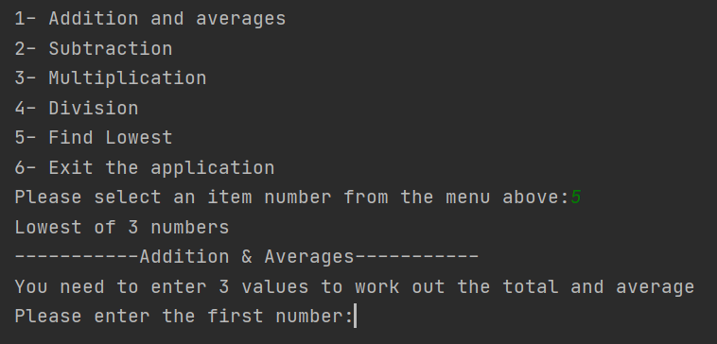

***Screen Dump of Actual Test Run showing Syntax error fixed***

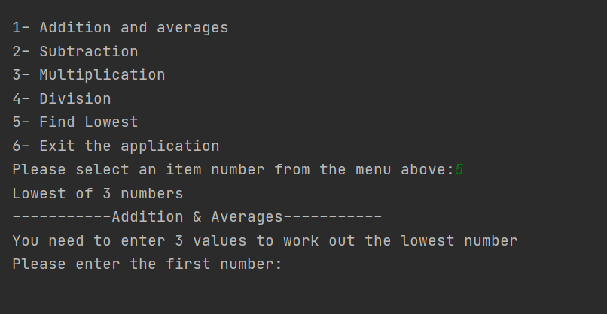

***Fig 1b***

***Screen Dump of Actual Test Run showing Logic error***



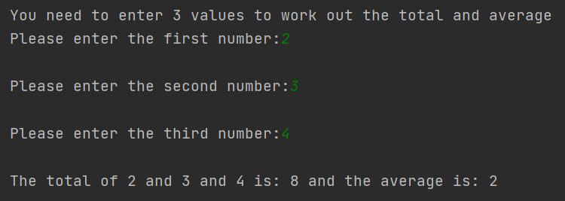

***Fig 2a***

***Screen Dump of Actual Test Run showing Logic error fixed (and average displayed as a number with a decimal place)***





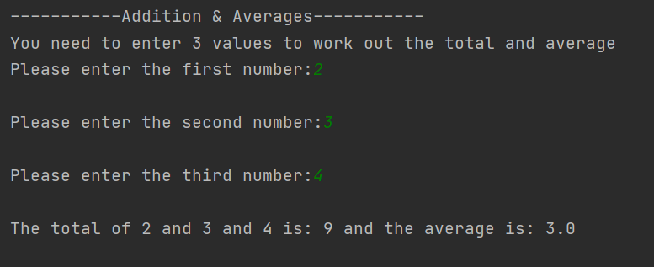



***Fig 2b***

***Screen Dump of Actual Test Run showing Run -Time error***

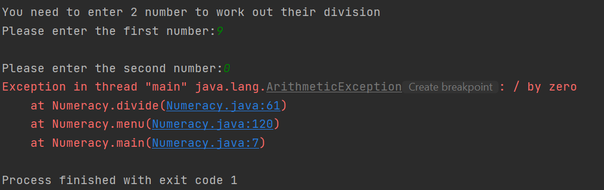

***Fig 3a***

***Screen Dump of Actual Test Run showing Run -Time error fixed***

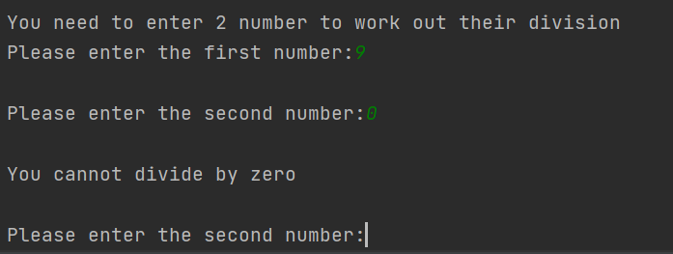

***Fig 3b***

***Examples of Internal Testing Documentation for Project: Numeracy***

{------------------------------------------------------------}

{ProgramIdentification Section}

{------------------------------------------------------------}

{Program: Numeracy.java}

{Program’sName: Numeracy}

{VersionNo.: 01}

{Date Written: 04/05/2021}

{Author: Linda Smite (Programmer.}

{Language: Java}

{------------------------------------------------------------}

{Description: A program to help young children at Dundee Primary School with their understanding of numeracy and in particular averages of numbers.}

{------------------------------------------------------------}

{Type of error: Syntax}

{Description: The wrong message is displayed after selecting option 5}

{Type of error: Logical}

{Description: The wrong operator (+ instead of *) is used when calculating multiplication}

{Type of error: Run-Time}

{Description: The program crashes when dividing by zero}